
FIVE RIVERS AREA OF NA (FRASCNA)
August 23rd, 2026
Mosaic Church
A.) Call to Order -2:00pm
- Moment of Silence/Serenity Prayer – Raychel L
- 12 Traditions – Jim
- 12 Concepts – Jen P
- Service Prayer – Nick B
- Motion to Approve Previous Minutes – Passed

B.) Roll Call

Group Name | Present (P) Absent (A) | Group Name | Present (P) Absent (A)
Blinking Light | P | Serenity Down South | P
Entirely Ready | A
Fairborn Basic Text | A | Surrender from Self | P
Guiding Principles | P | The War Is Over | P
Living the Dream | P | True Blue | P
More is Being Revealed | A | Women Do Recover | P
Never Alone | P | Atmosphere of Recovery | A
New Alive | P
One Step at a Time | A
Point of Freedom | A
Recovering Users | A

B.) Roll Call /Reports Attached in section H

- Chairperson: Raychel L
- Vice Chair: Bob B.
- Secretary: Chelsea D.
- Vice Secretary: OPEN
- Treasurer: Ally K.
- Vice Treasurer: OPEN
- RCM: OPEN
- RCMA: OPEN
- Local Services: Jen P.
- Literature: Dave S.
- Policy: OPEN
- Activities: Dave E.
- Ad Hoc Report: In the caring hands of Treasure

- D.) Open Forum

  - Martha – “Being of Service” pamphlet, bringing a level of awareness.
  - Martha – has willingness to attend Regional Meeting since RCM is empty.
    - Discussed that Bob B has willingness to fulfill the Regional Meeting viz Zoom.
  - Martha – stickers with QR code have been brought to Area to pass to GSRs if wanted to place on literature

- Policy Reading: Appendix D) Definitions

E.) Old Business
- OPEN POSITIONS TO TAKE BACK TO GROUPS
  - LSC: Secretary, Vice Chair, Outreach, Flyers, Phones & PR
- SPIRIT OF ROTATION, PLEASE TAKE BACK TO GROUPS OPEN POSITIONS.
  - Literature Chair
  - Vice Secretary
  - Vice Treasurer
  - RCM
  - RCMA
  - Policy

F.) New business.
- Decided at an Area Level we would go ahead and print the “Being of Service” pamphlets. Martha has willingness to facilitate the printing.

G.) Motion to Close – 2:33pm

H.) Attached Reports

- Activities Report:

- Treasurer Report: Below

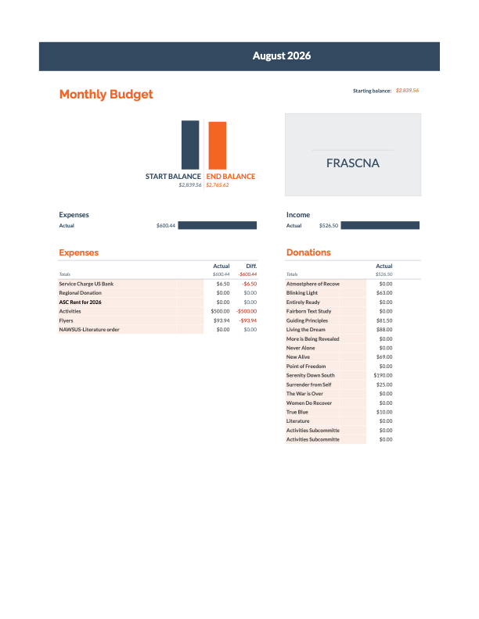

- Literature Report:

- LSC Report : Below

- Policy Subcommittee Report – POSITION OPEN. No April Report Sent to Secretary email.

Group Reports:
Present
Blinking Light: Fridays 8:00pm-9:15pm Mosaic Church
Doug S representing group at area this month
GSR – Doug S. Secretary- Steve Z. Treasurer-
Rotating Format
Area Donation:
Literautre Order: $63

Report: We have a rotating format that consists of; Literature study, Stick, Meditation, Speaker, and a Ticket meeting

Meeting is doing well. rent is paid, traditions are being followed. We have an average of 15 addicts, and 1-2 newcomers per meeting.

Women Do Recover: Monday 6:30pm-7:30pm - Be Hope Church in Beavercreek
Rotating Format
GSR: Katie
Teasurer: Sandi B
Secretary: Emily
Area Donation:
Literature Order:
Report: Meeting is going well. Attendance is increasing- around 15 women a week this last month. Would love to have more women with clean time/recovery to help support carrying the message.

Living the Dream: Monday 7:00-8:15 - 444 country club Dr
GSR - Bob B Secretary- Kyle H Treasurer- Taylor M
Chairperson choice rotating format
Area Donation:
Literature Order:

The War is Over: Saturday 7pm - St George Episcopal - 5520 Far Hills Rd
GSR – Helen N – Alternate - Devon
Secretary: Open
Treasurer: Martha
Area Donation:
Literaure Order:
Never Alone: Saturday 7:30PM-9:00PM - 202 S Winter St, Yellow Springs, OH
GSR – Mary D
Treasurer – Mary D
Topic discussion
Area Donation:

Guiding Principles: Wednesday nights 7:00pm-8:00pm – Hillside Chapel
Rotating Text Study
GSR: Brad
Area Donation:

Report: No report provided.

True Blue: Sunday 6-7:15 - Peace Lutheran Church
Rotating format: Currently reading: Basic Text
GSR:
Secretary: Tim B
Treasurer: Amanda M
Literature Order: $10
Area Donation: $33.33

Report: True Blue is meeting face to face and is averaging 5-15 people. We have approximately ($33.33) literature order from last month. We have a $10.00 donation. We have changed our format and we do a rotating format. We coordinate step study meetings. January is step one and tradition one. February is step two and tradition two, etc. we have a speaker on the third Sunday of the month on the coordinating step for the month.
Serenity Down South: Monday 7:00-8:15 - 63 East Franklin St, Centerville, OH 45459
GSR – Jim T
Secretary: Max L
Treasurer: David C

Area Donation: 190
Literaure Order: $44
OPEN meeting, rotating format
Report: Rotating format, 8 - 15 addicts in attendance, this Monday is a speaker meeting

Never Alone: Saturday 7:30PM-9:00PM - 202 S Winter St, Yellow Springs, OH
GSR – Mary D
Treasurer – Mary D
Topic discussion
Area Donation:

No Report provided.
Surrender from Self: Sundays 7:00 pm-8:00 pm - Seventh Day Adventist - 3939 Stonebridge Rd
GSR- John S.
Rotating format
Area Donation:
Chairperson choice format. 5-15 addicts per week.

No Report provided.

New Alive: Tues 7:45-9:00 - St Marks Church - 456 Woodman Dr Tues 7:45-9:00 - St Marks Church - 456 Woodman Dr
GSR – Ryan H
Rotating format
Area Donation:
Report:

Absent
Sunday Night Stepping Out
One Step at a Time: GSR - Pam
6:30-7:30 - Tuesdays - The Hope Spot - 529 W Second Street, Xenia
Rotating Format

No Report provided.
Recovering Users: GSR – Nick B
Tuesday 8:00-9:00 - 333 N Broad St Fairborn, Oh
Topic discussion

No Report provided.

Entirely Ready: GSR – Amy J
Tuesdays 7:00pm Parkview church 4701 Far Hills Ave, Dayton
Report: Verbal
No Report provided.

More is Being Revealed: GSR – Ben
Thursdays at 7:00-8:00pm (15 mins to share if needed after 8pm) - Fairmont Presbyterian Church in basement - 3705 Far Hills
Area Donation:
Report: No Report Given.

Atmosphere of Recovery: Fridays 6:30pm-7:30pm – 47 East Franklin st. Bellbrook, OH – Bellbrook United Methodist Church
GSR - Zach
Rotating Format

No Report provided.
Point of Freedom: Thursday 7:30-8:30 - Alpha Community Church - 806 Alpha Rd
GSR - Deanna M
Treasurer: Myssi Z
Weekly rotating candlelight meeting
Literature Order:
Area Donation:

Report: No Report Provided

Fairborn Basic Text: 7:30pm - 8:30pm- 333 North Broad Street
Secretary: Josh
Treasurer: Jake S
GSR - Lori
Text Study
Area Donation:
Literature Order:
Report:

