

FIVE RIVERS AREA OF NA (FRASCNA)

January 26, 2025

Mosaic Church

**A.) Call to Order - 2:03**

* Moment of Silence/Serenity Prayer - Katis S
* 12 Traditions - Max
* 12 Concepts - Brad
* Service Prayer - Daniel
* Motion to Approve Previous Minutes - Approved

**B.) Roll Call**

* New GSRs/Groups - None
* Total voting members present: 9

| Group Name | Present (P) Absent (A) | Group Name | Present (P) Absent (A) |
| --- | --- | --- | --- |
| Blinking Light | A | Serenity Down South | P |
| Entirely Ready | P | Sunday Night Stepping Out | A |
| Fairborn Basic Text | A | Surrender from Self | P |
| Guiding Principles | P | The War Is Over | P |
| Living the Dream | P | True Blue | A |
| More is Being Revealed | A |  |  |
| Never Alone | P |  |  |
| New Alive | P |  |  |
| One Step at a Time | A |  |  |
| Point of Freedom | P |  |  |
| Recovering Users | A |  |  |

**B.) Roll Call /Reports Attached in section H**

* Chairperson: Katie S- Report attached
* Vice Chair: Ally K
* Secretary: OPEN (Katie)
* Vice Secretary: OPEN
* Treasurer: OPEN (Ally)
* Vice Treasurer: OPEN
* RCM: Martha B - Report attached
* RCMA- OPEN
* Local Services: Helen N - Report Attached
* Literature: Dave S - Report Attached
* Policy: OPEN
* Activities: Dan G - Report Attached
* Ad Hoc Report:Doug S- US Bank Committee Report Attached
* Group Reports (See section H)

**D.) Open Forum**

* Section of policy that was read and reviewed: Secretary position

**E.) Old Business**

Motions that were taken back to groups to review and vote on:

1. [LSC] Will bring 300 printed schedules quarterly to the ASC.

Intent: to specify the amount for LSC to bring to the area quarterly.

Yes- 9

No-0

Abstentions-0

**Motion passed**

1. Motion brought by Serenity Down South

Motion: Five Rivers area conducts a biennial convention each year, beginning in 2026, the third weekend of February at a location to be determined by a convention committee. Five Rivers area will form a convention committee of which Serenity Down South will participate year 1 to help initiate this annual event. Event can be increased to annual event if deemed appropriate by area and committee

INTENT: To give the Five Rivers Area a staple event which will help carry the message of recovery to all that attend while also giving more service opportunities and resources for addicts to experience recovery in our area. Any funds raised will also be another area of resource for the Five Rivers Area.

Yes- 1

No- 4

Abstentions- 3

**Motion failed**

**F.) New Business (Two items for group vote/review)**

1. Maker of the Nomination: Helen, LSC Chair

Seconded by: Brad K, GSR for Guiding Principles

Who: Chelsea D for secretary

Qualify: “3/12/22 (clean date) GSR quit due to irresponsibility but willing to commit now”

1. Maker of Motion: Helen, LSC Chair

Seconded by: Bob, GSR for Living the Dream

Motion: To add subcommittee chairpersons to the secretary position in policy

Intent: To keep communication flowing with all area service members

*\*This motion is typed out exactly as written. To clarify, as this motion may need to be amended at the next area meeting, it is requesting to add all subcommittee chairpersons to the area secretary’s distribution list when sending out the monthly area minutes\**

**G.) Motion to Close** - 3:09

**H.) Attached Reports**

**Chair:**

Katie S- Ally and I met with Freddie and reviewed the treasury records that he was maintaining during his term of service. Freddie kept everything very organized. We weren’t able to complete the audit, however, since we weren’t able to access the bank account online. We will need to reconnect with Freddie to finish the audit. We are going to add Ally to the banking account. She will be covering the treasury position until it is filled and I will be covering secretary. Please be patient as we try to manage the admin responsibilities until we get all of the open positions filled. ILS, Katie

**Vice Chair:** Ally K- verbal report

**Secretary:** OPEN

**Vice Secretary:** OPEN

**Treasurer:** Report provided by Ally K

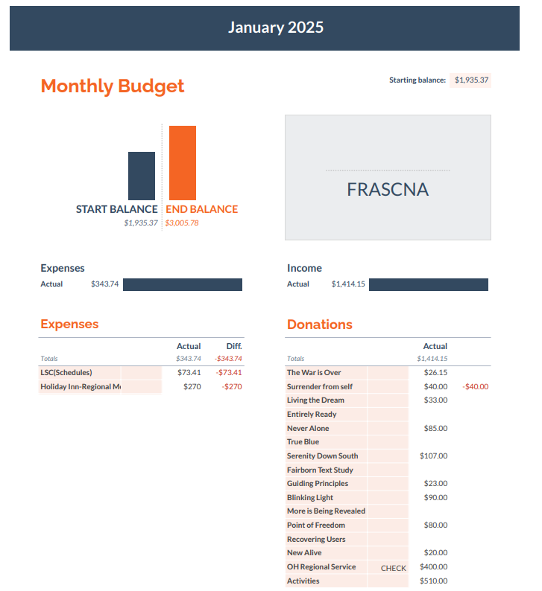

***Treasury cont’d***

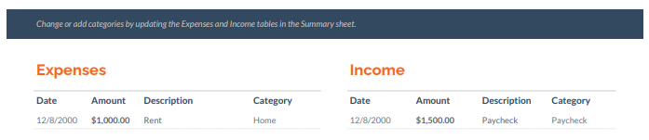

**Vice Treasurer:** OPEN

**RCM-** Martha

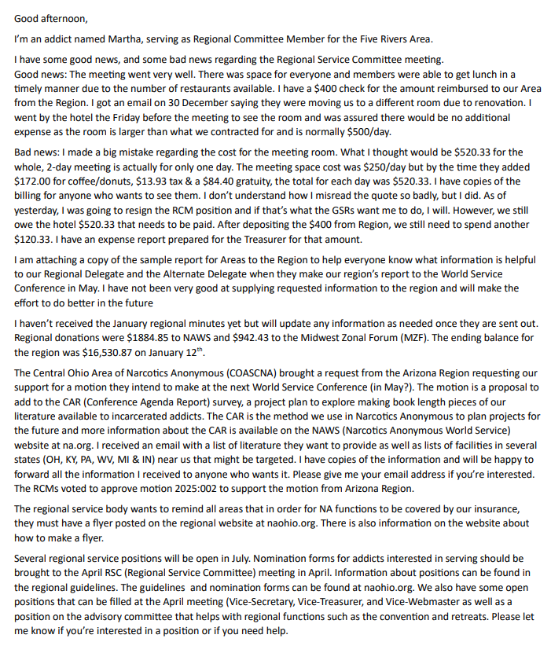

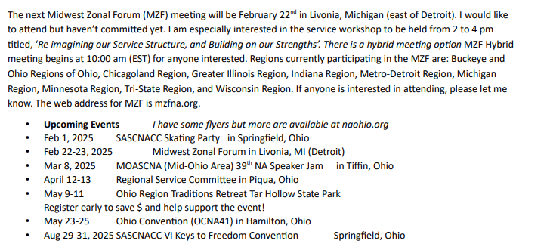

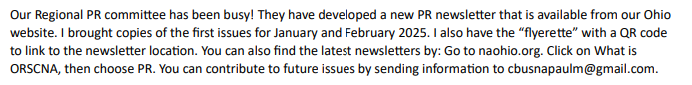

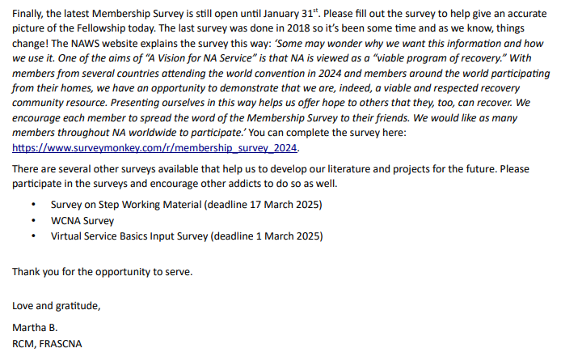

**RCMA**: OPEN

**Local Services Coordinator Reports:** Provided by Helen (reports taken from LSC minutes)

* **Chair:** Area asking for 300 schedules for area meetings quarterly, wants that put into policy, groups should be voting on it.
* **H&I:** Hello FRASCNA, Nothing new to report for this month. meetings are going well. We have plenty of literature. ILS Doug S
* **Website:** I added an updated area policy to the website and made a few corrections to meeting times on Ohio.NA. (nothing that needs to be changed on our paper schedule). I also worked with other addicts to update our help wanted page as well as fix a broken link the website had for the activities committee. All meeting times and flyers should be up to date. Thank you for letting me be of service- Britt B
* **Phoneline:** -Nick-2 calls last month
* **PR**-Jeff-has no report at this time
* **Outreach**:- At our December Outreach meeting, we discussed presenting a Service Learning day at the group level to our assigned meetings. Survey to HG members is as follows:
  + -Does your group want to Learn more about service?
  + -Would your group like to learn how service can positively impact your recovery?
  + -Would your group like to hear ESH on how service can positively impact your recovery?
  + -Groups interested in Group Level Service Learning day will be rotated as Meeting Of the Month was.
  + -We will offer the group options of panel or speaker

**Literature:** The starting literature balance in December was $107.57; after fulfilling all of the December orders the balance is $556.13. No order was placed so there are ten step working guides and five red key tags are back ordered. Best, Dave S

**Policy:** OPEN

**Activities:**

The Activities Committee held an event on New Year's Eve, 2024. We had over 80 people in attendance. We raised money and are returning $510 to Area. We had a DJ who played live music. There was dancing. There was a speaker. We watched the ball drop. Members came from Hamilton, Troy and Springfield to participate in the event. Overall the event was a success. Also in 2024, Activities held a Spiritual Breakfast in Xenia in March, a {Picnic in Beavercreek in July, a Halloween Party in Centerville in October, and the New Years Eve Party in Centerville. We met our requirement for 4 events. The committee is growing its membership and more ideas are coming in for future events. For our first event of the year we are looking at options for laser tag and/or bowling. In Loving Service, Daniel G.

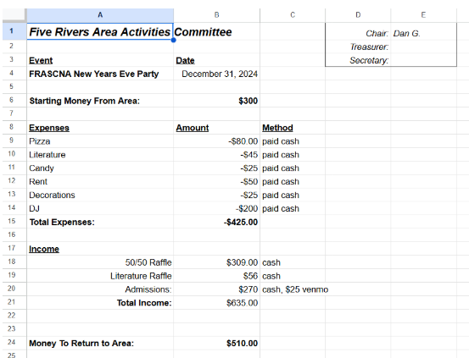

**Ad Hoc Committee:**

Hello FRASCNA

Here's action items from this past month. I spoke with our US bank account representative about the following items. I'm going to add the information.

1. 1.Debit card-
   1. We can add literature chair to our bank account and have a debit card assigned to that person only.
   2. Bank has fraudulent protection on all transactions as a safeguard.

(New business to discuss and check policy)

1. How to get online access: Member must be on account and has to create a username and password
2. Add/removing persons from account-Members can be added and removed by bank representative with the authorization by members already on account.
3. Ordering duplicate checks - Bank has duplicates for $36/50 checks. Had bank change address to P.O. Box and send an order to.
4. Checking on discounted literature orders, Everything I've found is same price as WSO
5. Check on donations through bank created link. I have detailed information on cost and all services bank can offer us if area is interested.

I still need to update our shared google sheet with this information, I will get that done today.

(Will need to update area policy with some of this information as a matter of information.)

Please let me know how area would like to proceed with any of this information and if there is anything else I can do to be of service. ILS Doug S

**Group Reports:**

| **Present** |
| --- |
| **Living the Dream:** GSR - Bob B Secretary- Kyle H Treasurer- Taylor M  Monday 7:00-8:15 - 444 country club Dr  Chairperson choice rotating format  Lit order:  Donation:  Report: Had 15th Anniversary meeting on 1-27-25. 30-50 addicts in attendance. Several treatment centers attended |
| **Serenity Down South:** GSR – Max L  Monday 7:00-8:15 - 63 East Franklin St, Centerville, OH 45459  Closed meeting, rotating format  Lit order: One step working guide ($10.76)  Donation: $107  Report: 6-12 on average |
| **Never Alone:** GSR – Martha B  Saturday 7:30PM-9:00PM - 202 S Winter St, Yellow Springs, OH  Topic discussion |
| **New Alive:** GSR – Ryan H, Jenna in attendance for Ryan  Tues 7:45-9:00 - St Marks Church - 456 Woodman Dr  Rotating format |
| **Surrender from Self:** GSR- Daniel R  Sundays 7:00 pm-8:00 pm - Seventh Day Adventist - 3939 Stonebridge Rd  Rotating format |
| **The War is Over:** GSR – Dan G  Saturday 7pm - St George Episcopal - 5520 Far Hills Rd  Rotating format  Our meeting is doing well, averaging 15 to 20 addicts per meeting. Our meeting has a chairpersons choice rotating format. This month we had a literature order of $87 and an Area donation of $26.15. |
| **Guiding Principles:** GSR - Brad K Alt - Hip  Wednesdays 7-8pm - Hill Side Chapel - 3515 Shakertown  Literature study - Living Clean |
| **Point of Freedom:** GSR - Deanna M GSR alt - Jonathan S  Thursday 7:30-8:30 - Alpha Community Church - 806 Alpha Rd  Weekly rotating candlelight meeting |
| **Entirely Ready:** GSR – Amy J  Tuesdays 7:00pm Parkview church 4701 Far Hills Ave, Dayton  Lit Order: $145.80 (From last month)  Donation: 0  Report: Bigger attendance. 30 + addicts weekly. We are attempting timing shares but we haven’t been consistent yet |

| **Absent** |
| --- |
| **Blinking Light:** GSR – Travis Secretary- Erik Treasurer- Steve Z  Fridays 8:00pm-9:15pm Mosaic Church  Rotating Format |
| **Fairborn Basic Text:** GSR - Jake S. Alt- Ky  7:30pm - 8:00pm- 333 North Broad Street  Text Study- Basic Text |
| **More is Being Revealed:** GSR – Carrie  Thursdays at 7:00-8:15pm - Fairmont Presbyterian Church in basement - 3705 Far Hills Ave Rotating topic/literature from It Works: How and Why |
| **One Step at a Time:** GSR - Pam  6:30-7:30 - Tuesdays - The Hope Spot - 529 W Second Street, Xenia  Rotating Format |
| **Recovering Users:** GSR – Nick B  Tuesday 8:00-9:00 - 333 N Broad St Fairborn, Oh  Topic discussion |
| **True Blue:** GSR – Stephanie B  Sunday 6-7:15 - Peace Lutheran Church  Rotating format |